**Project 2 Report**

1. **Student Name(s) and e-mail addresses** 
   * Fredrik Persen Fostvedt : [fpfostvedt@gmail.com](mailto:fpfostvedt@gmail.com)
   * Padmaja Matlaparti : [mpadmaja@pdx.edu](mailto:mpadmaja@pdx.edu)
   * Vinutha Veerayya Hiremath : [vinutha@pdx.edu](mailto:vinutha@pdx.edu)
2. **Project Name**

Know ur Grades

**Goal of the project**

This application helps the students to know their grades. They are also given an option to say the term for which they want to hear their grades or they can say the course name or course id to hear the grade for a particular course.

**Intended user of the application**

Students

1. **Example usage scenario(s)**

Jesse is on a road trip and she is driving. She wants to know her grades for **fall**. Since her hands would be busy she uses our voice enabled application to listen to her grades for **fall**.

System: Welcome to know your grades voice application. Please have the student I D ready for veri fication.

System: Please say the user name

Jesse: <username>

System: Now, Please read out the student ID

Jesse: <student ID>

System: Please choose between Course, Term, G P A or quit.

Jesse: term

System: Please say the term name such as Fall.

Jesse: fall

System: Courses and Grades for fall term

<**CS 510 Spoken Language Interfaces** **A>**

<**CS 553 Design Patterns** **A-**>

<**CS 560 Human Computer Interaction** B>.

System: Would you like to know your g p a for this term??

Jesse: Yes.

System: Your GPA for **fall** is **3.65.**

System: Do you wish to know your grades for other terms or courses. Please say yes to continue and no to exit the application.

Jesse: No.

System: Thank you for using Know your grades application. Good Bye..

1. 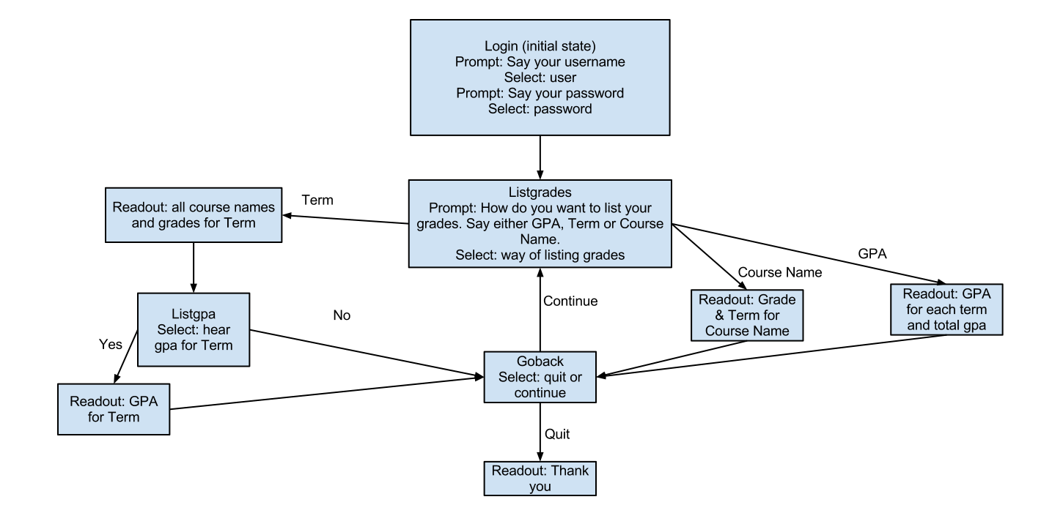**Content model of the application**
2. **User Testing**
   1. Spontaneous generation of words spoken by the user (for user directed dialogs, this includes commands; for system-directed dialogs, this includes words spoken by the user)

Because most of the dialogues in the application were close ended questions there were not many words generated by the users

Commands:

* Course
* GPA
* Yes
* No
* Exit
* Term
  1. Confidence rating words spoken by the user (for user directed dialogs, this includes commands; for system-directed dialogs, this includes words spoken by the user)

|  |  |
| --- | --- |
| **Commands** | **Confidence rating of words on 1 to 5** |
| Term | 4.3 |
| Course | 4.75 |
| GPA | 5 |
| Yes | 4.3 |
| No | 4.8 |
| Exit | 4 |

* 1. ASR test to recognize similar sounding words (verify the ASR can recognize words correctly)

|  |  |  |
| --- | --- | --- |
| **Commands** | **Confidence rating of words on (1 to 5)** | **ASR Test** |
| Term | 4.3 | 0/10 |
| Course | 4.75 | 1/10 |
| GPA | 5 | 0/10 |
| Yes | 4.3 | 0/10 |
| No | 4.8 | 0/10 |
| Exit | 4 | 1/10 |

* 1. Wizard of Oz tests

System: Welcome to know your grades voice application. Please have the student I D ready for veri fication.

System: Please say the user name

Jesse: <username>

System: Now, Please read out the student ID

Jesse: <student ID> (There was a lot of noise)

System: To listen to your grades please choose between Course, Term, G P A or quit.

Jesse: no input

System: I am sorry I could not hear you please choose between Course, Term, GPA or quit.

Jesse: term

System: Please say the term name such as Fall.

Jesse: winter

System: Courses and Grades for fall term

<**CS 510 Spoken Language Interfaces** **A>**

<**CS 553 Design Patterns** **A-**>

<**CS 560 Human Computer Interaction** B>.

System: Would you like to know your g p a for this term??

Jesse: No. (the user started talking in the middle of the prompt and we stopped the prompt, listening to her.)

System: Your GPA for **fall** is **3.65.** (Continuing with test)

System: Do you wish to know your grades for other terms or courses. Please say yes to continue and no to exit the application.

Jesse: No.

System: Thank you for using Know your grades application. Good Bye.

* 1. Usability test
* How clear were the options you were given?
  + [1-5]: 4
* How easy was it to achieve the goals you were given?
  + [1-5]: 5
* How certain were you that you were making the right choices to achieve your goals?
  + [1-5]: 4
* How well did you feel the software responded to your choices?
  + [1-5]: 5

**Learnings from testing**

From the testing we learned that the main problems of the application were:

* + - * inability to recognize specific words, like username, fall etc.
      * vague menu options
      * vague questions in testing

The testing led us to revise the application in the following ways:

* + - * Changed the menus to be more specific. Explicitly stated what kind of information each menu option could provide you with.

### Qualitative Questions

What did you like and what did you not like about the experience of using the automated know your grades system?

Layout of option tree, limitation on term repetition.

How do you think the system can be improved?

Better speech recognition engine.

### Evaluation by tester

How many times did they have to retry to go down the scenario path? 6

How many times did they attempt to access each next step in the scenario? many

How many times did they pick the wrong next step? 1

### Observations while testing

The user was frustrated that the engine stopped reading the prompts before he knew what they were. A possible solution is to turn off voice input during prompts.

The user had to retry because he went the wrong path. He was looking for course names for fall, but chose course. A possible solution could be to make the menu choices more explicit or to add more options to each branch in the menu.

The user could not find the term ‘fall’. This is because the engine did not recognize the word fall. This is an engine/microphone problem. No solution can be found at this point.

The user tried to quit the application and failed because it gave off an error. Solution, correct the syntax in the vxml doc.

1. **Development effort**
   * 1. Initial time estimates for each team member and task

|  |  |
| --- | --- |
| **Manpower estimation** | **Work Description** |
| 8*3 =24 | To have a refined content model and to get acquainted with voxeo platform. Start off with login message and validation of name or id entered. |
| 8*3 = 24 | Start with coding based on the finalized working model and have a basic working application by end of the week. |
| 8*3 = 24 | Error handling – handle all the error cases such as mumbling, noises, no-input from the user . |
| 8*3 = 24 | Testing – Basic flow, all the error scenarios and prepare for presenting the application to the class. |
| 15 mins | Project report and demo. Get good grades ☺ |

* + 1. Actual time estimates for each team member and task

|  |  |  |
| --- | --- | --- |
| **Manpower** | **Work Description** | **Total** |
| 4*3 =12 | A refined content model and to get acquainted with voxeo platform. Start off with login message and validation of name or id entered. | 12 |
| Vinutha: 4  Fredrick:4  Padmaja: 3 | Start with coding based on the finalized working model and have a basic working application by end of the week. | 11 |
| Vinutha: 3  Fredrick:4  Padmaja: 3 | Error handling – handle all the error cases such as mumbling, noises, no-input from the user. | 11 |
| Vinutha: 3  Fredrick:4  Padmaja: 4 | Testing – Basic flow, all the error scenarios and prepare for presenting the application to the class. | 11 |
| 15 mins | Project report and demo. Get good grades ☺ | 45hours |

1. **Instructions for accessing the application**

The user can call the application using a phone or cell phone; following are the instructions for accessing the application via phone*:*

*Enter your user name and user id*

*Say course, term or gpa to retrieve information about a specific course, term or to get the overall gpa.*

*When in either of the menu options, select a course to get a grade for, term to list courses for or hear your gpa.*

*After this say yes if you want to continue using the application or no if you want to quit.*

1. **Implementation**

The application was implemented as a voxeo application in a single xml file. The implementation can be found in the folder 'Know-Your-Grades voxeo application'.  
  
The latest revision is 'login_page.xml'

The first revision that was changed after testing data was gathered is 'login_page_version_0.xml'

1. **What you by designing and implementing this application**

* Learn about how voice applications are created.
* Learn about man and machine interactions.
* Learning more about our xml.
* Learn how to test the voice applications.